**DIRECTIONS FOR LOGGING INTO GOOGLE MEETS**

**STEP 1:** Type Meet.Google.com into the address bar.

**STEP 2:** Click Sign In and sign in with your usual GSE credentials.

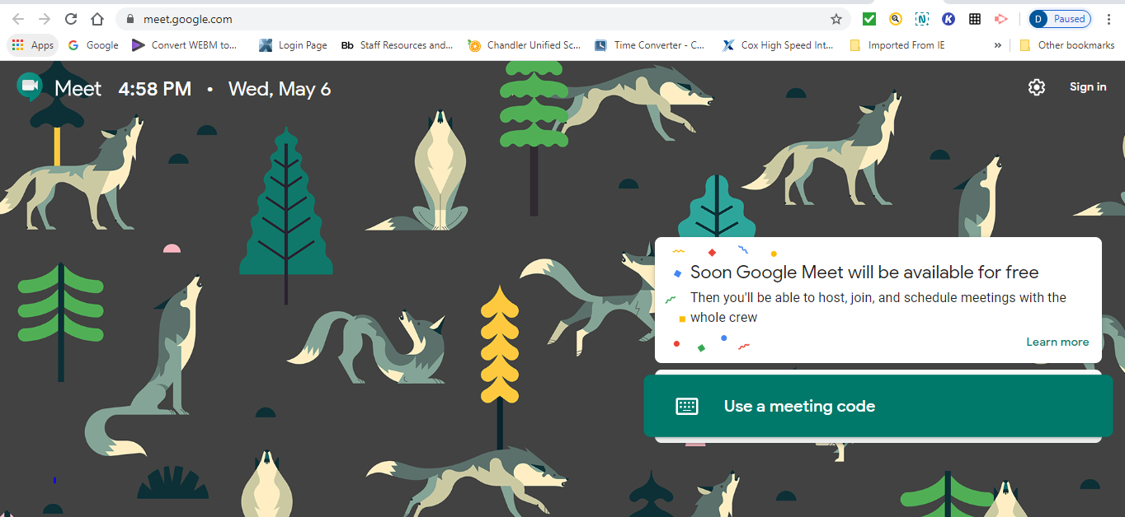

**You can tell you are signed in because in the top right will show your initial.**

**STEP 3:** Click Use a Meeting Code.

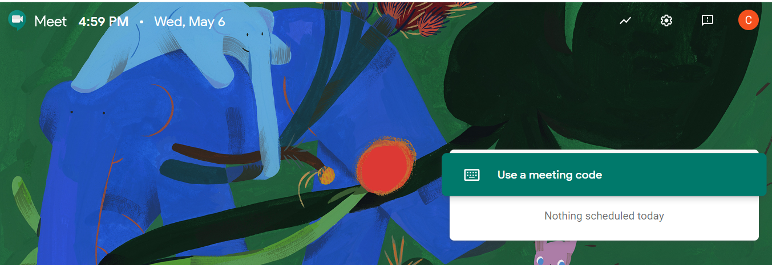

**STEP 4:** Enter the code: RISEUPREDSEA and then click Enter.

